3B Physics: Particles, Waves and Quanta

Assignment Two
Name: Possible Answer Key (60 marks)
- You know that electromagnetic radiation exhibits a “dual nature”. With examples, explain
what is meant by a “dual nature”? (2 marks)
Duel nature in that electromagnetic waves exhibit both wave-like and particle-like properties.
Wave-like in that they show wave behaviours such reflection, refraction and diffraction.
Particle-like is shown by spectra and the photoelectric effect.

- A neon sign emits photons of wavelength 7.10 x 10⁻⁷ m.
- To which region of the electromagnetic spectrum do these photons belong? (1 mark)
visible light (colour is red but that is not required)
- What is the energy of the photons in electron volts. (3 marks)

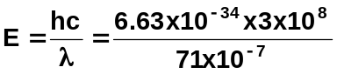 (1 mark)

E = 2.8 x 10⁻¹⁹ J (1 mark)

in eV
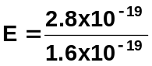
E = 1.75 eV (1 mark)

- An advertisement for a new laundry detergent boasts:
“DAZZLE laundry detergent makes your clothes WHITER than WHITE.”
Describe how laundry detergent manufacturers can cause clothes to appear to produce white light. (3 marks)

Laundry detergent contains chemicals that appear to produce their own light.
These chemicals absorb non-visible light (UV radiation) which excites electrons to a higher level.
As the electrons return to ground state, they emit photons of frequencies within visible light and it is this transition that gives the “whiter than white” appearance.

- Look at the two spectrums below. Name the type of spectrum produced in each case, A and B, then explain the formation of each including an example. (6 marks)
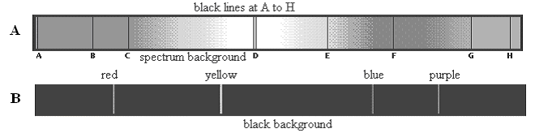

- Absorption spectra are that which is obtained by the dispersion of light that has passed through some absorbing material.
In this type of spectra we see black lines superimposed onto a continuous spectrum which represents the absence of light within the spectrum.

The solar spectrum contains a series of black lines in an otherwise continuous spectrum.

- Emission spectra
Spectrum obtained by the dispersion of light coming directly from the source
e.g. from glowing gas discharge tube or emissions from hot nebulae or quasars.

- Explain the difference between a photon and a quantum. (2 marks)
Photon: Bundle of energy moving in a wave-like motion.
Quantum: Amount of energy each photon contains.

- When looking at the sun through a spectroscope, a spectrum can be seen which has thin black lines on it.
  - What is the name given to this type of spectrum? line absorption spectrum 1 mark)
  - What is the name given to these black lines?
Fraunhofer lines (1 mark)
  - Why do they occur? (2 marks)
Light from the sun passes through the atmosphere’s of the sun and Earth. Photons of frequencies corresponding to the line emission spectrum of the atmospheres will be absorbed thus producing black lines in full coloured spectrum. Thousands of lines have now been catalogued.

- a. Look at the energy level diagram for an atom. How many possible transitions are there for this
atom (write the number in the space provided below), draw them. (2 marks)

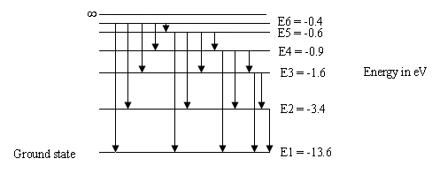

Number of transitions = 15

- In the energy transition diagram above, what would happen if an electron were given 14.8 eV?
What name do we give to this? (2 marks)

This is called ionisation.
The electron would leave the atom

- An electron in the diagram above is given enough energy to jump to the third level. It then returns to ground state via the second level where it emits light. What colour is the light?
(4 marks)

E₃ – E₁ = (3.4 – 1.6) x 1.6 x 10⁻¹⁹
= 2.88 x 10⁻¹⁹ J (1 mark)

3.88 x 10⁻¹⁹ = 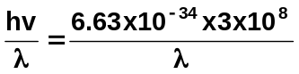

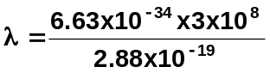
λ = 6.91 x 10⁻⁷ m (2 marks)
colour is red (1 mark)

- A microwave has a frequency of 3.40 x 10¹⁰ Hz. If the microwave has a power output of 900 W, how many photons per second are transmitted? (2 marks)

E = hf
= 6.63 x 10⁻³⁴ x 3.40 x 10¹⁰
E = 2.2542 x 10⁻²³ J per photon (1 mark)

now P = W/t and work = energy so 900 W is 900 J per second

number of photons = 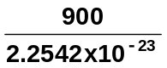
= 3.99 x 10²⁵ photons per second (1 mark)

- Strong nuclear forces hold protons and neutrons together. Protons and neutrons are hadrons and each hadron is made up of three quarks. There are six types of quarks each of which has a fractional charge. Up-type quarks have a charge of +2/3 electric charge, while down-type quarks have -1/3 electric charge. If an electric charge is the charge on an electron, determine the quarks that make up a neutron and a proton. You must show your working to justify your answer.

- a neutron (2 marks)

neutrons are neutral so (+2/3) + (-1/3) + (-1/3) = 0
so an up + down + down

- a proton (2 marks)

protons have a charge of +1 so (+2/3) + (+2/3) + (-1/3) = +1
so an up + up + down

- While astronomers still use light telescopes to view the universe, much more information is available by using other waves within the electromagnetic spectrum such as radio-waves, infra-red waves, ultra-violet waves and X-rays. Select ONE of these and explain what information is available that is not visible using a light telescope. (3 marks)

Answer depends on what the student selects. Some very brief information is below.

Radio Astronomy – can penetrate dust so study can study dust-shrouded environments
such as where stars are born

X-Ray Astronomy – objects that emit X-rays such as hot gases such as neutron stars and
black holes.

Infra-red Astronomy – used to look at new stars, asteroids and quasars.

Ultra-Violet Astronomy – (must be on a satellite as Earth’s atmosphere prevents ultra-violet radiation reaching surface) used to discern chemical composition, densities and temperature of interstellar medium.

- Label the following diagram showing the production of X-rays. (3 marks)
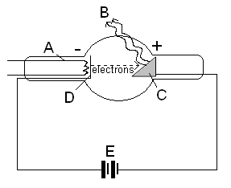
5 correct –
3 marks

4 correct –
2 marks

3 correct –
1 mark

A: Heating circuit

B: X-rays

C: anode target

D: cathode

E: high potential difference

- Describe and explain the following fundamental cosmological concepts.
- How red-shift is evidence of the Big Bang Theory. (3 marks)

Redshift of light is caused by the Doppler effect. When an object is moving away from the observer, the wavelengths are increased. In light, this causes a shift towards the red end of the spectrum – hence red-shift. The red-shift of galaxies we observe show they are moving away from us which is evidence of a large explosion – the big bang.

- The two proposed models for the behaviour of the universe. (2 marks)

Open universe – in which the universe will keep expanding forever.
Closed universe – where the universe has a finite size and will stop expanding. This depends on whether there is enough mass for gravity to stop the expansion.

- Hubble’s law, red-shift and the expanding universe. (2 marks)

Hubble discovered that the distances to different galaxies is proportional to the red- shift of that galaxy. The more the red-shift, the further away the galaxy. This is known as Hubble’s Law.

- A spaceship of the future is travelling at 90% the speed of light. It is travelling to Alpha Centauri B, which is believed to have a sister planet to Earth, to see if life is exists on this planet.
- If Alpha Centauri B is 4.32 light years from Earth, how long will it take for the spaceship to get to the planet? (2 marks)

time = 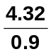
= 4.8 years

- When travelling close to the speed of light, time dilation occurs and the time for the passengers on the spaceship appears shorter. The apparent time, t₀, can be found using the time dilation equation and the actual time, t.

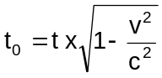
Calculate the apparent time according to the passengers. (2 marks)

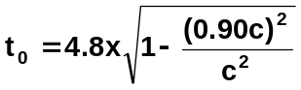
= 4.8 x 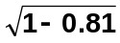
= 4.8 x 0.43589
= 2.09 years

- The spaceship can’t go any faster as due to Einstein’s equation, E = mc², when travelling close to the speed of light, some of the energy used to accelerate the spaceship is converted to mass. Using Einstein’s mathematical equation,
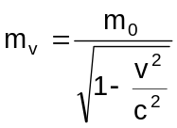 where m_{v} = the mass when moving and m₀ = the resting mass.

If the spaceship has a mass of 3.70 x 10⁶ kg when orbiting Earth, what will be its mass when travelling at 90% the speed of light? (2 marks)

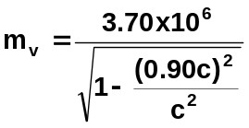
m_{v} = 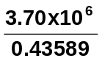
m_{v} = 8.49 x 10⁶ kg

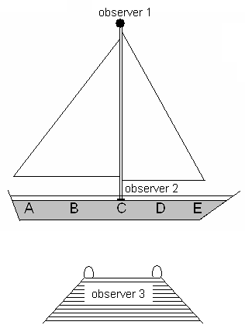
- Galileo described a thought experiment in which a sailor, observer 1, drops an object from the tall mast of a sailing ship which is moving at a steady velocity eastwards. Observer 2 is standing just to the right of point C. Observer 3 is on a jetty watching the sailing ship pass by.

At what position would you predict the object will land for

- observer 1: C
- observer 2: C
- observer 3: B

3 correct – 2 marks
2 correct – 1 mark

- A passenger on a train is walking at 2.50 m s⁻¹ towards the rear of the train. The train is travelling forward at 15.0 m s⁻¹. Relative to an observer on the ground nearby, what is the speed of the passenger? (2 marks)

speed = 15.0 – 2.50
= 12.5 m s⁻¹ forward

